
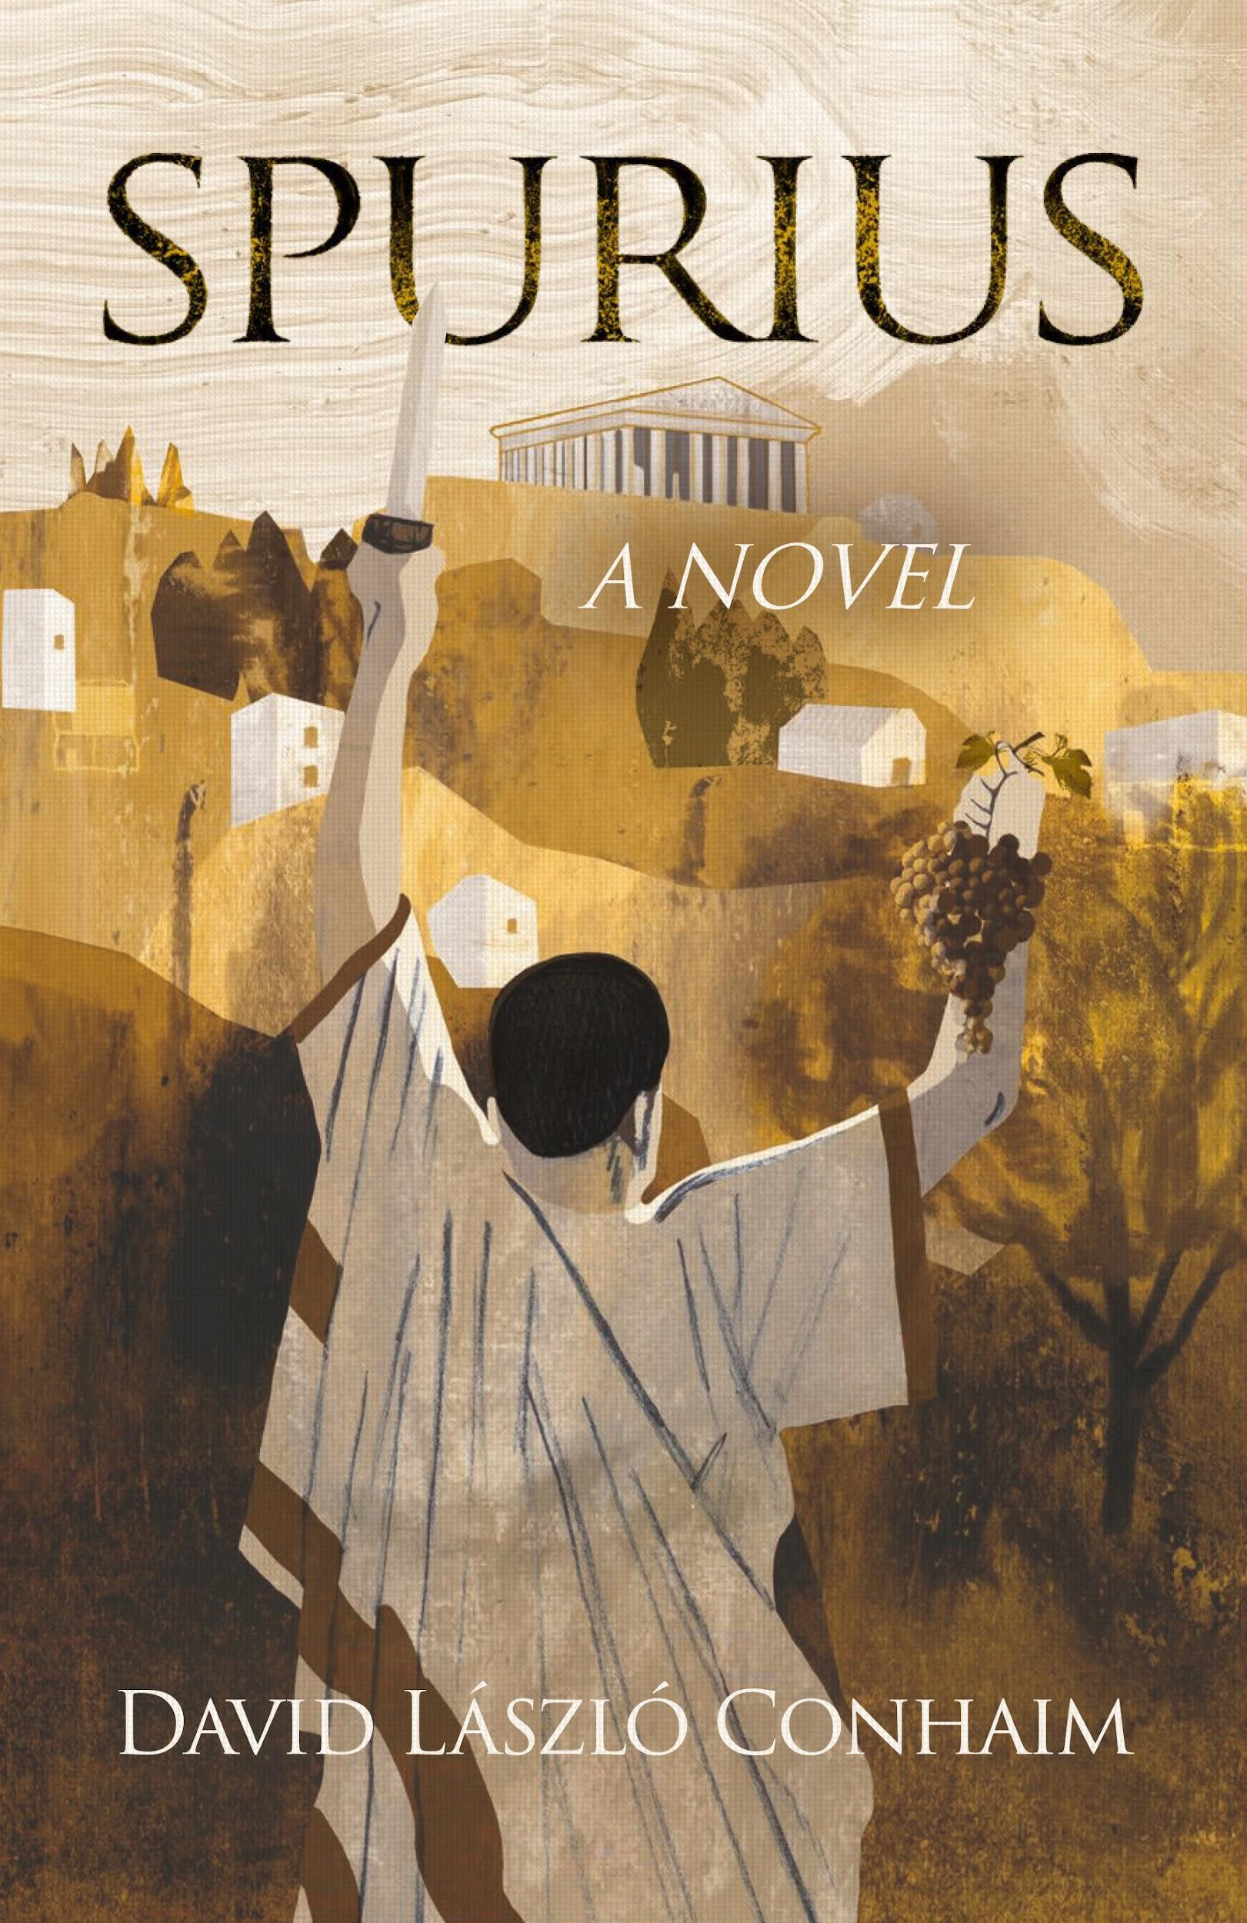
SPURIUS
A NOVEL
By David László Conhaim
Published by Kulturalis on 25 June 2026

- A political whodunit about power, moral panic and the cost of empire
- First novelization of real events recorded by Roman historian Livy
- Resonates with contemporary political climate
- “A fine amalgam of historical scholarship and literary invention.” Kirkus Reviews
- Luxury, illustrated edition of acclaimed novel

Set in the Roman Republic, SPURIUS is a political historical thriller set in one of the most charged episodes in Roman history. Presented as the “found” memoirs of Spurius Postumius Albinus, Consul of Rome in 186 BC, it revisits the suppression of the Bacchic cult: a moment of fear, violence and state power that feels strikingly relevant today.
While occupying Rome’s highest office, Spurius makes an alarming discovery: the priests devoted to the god of wine and ecstatic transformation oversee a secret society that “threatens the very heart of the state.” Or so he tells the Roman Senate. With the Sacred Fathers’ approval, he rounds up some 7,000 Bacchanalians and executes half of them. Is Spurius drunk on conspiracy theories and power? Or does he save the state?
Both a mystery and a meditation on the excesses of state authority, SPURIUS reveals a candid world of great-powers politics, eroticism, and violence, and, finally, how a republic begins to fail as it becomes an empire.
Vividly illustrated by Jorge González whose work includes William Golding’s Lord of the Flies and Carlos Ruíz Zafón’s The Shadow of the Wind, and hand lettering artist Ruth Rowland.
SPURIUS will be published on 25 June by Kulturalis priced $60
For further information, review copies and author interviews please contact: angela@angelaallan.co.uk
ABOUT THE AUTHOR
Born in Minneapolis, USA, David László Conhaim is a national award-winning author whose historical fiction is known for exploring themes of racial and social justice, identity, and moral struggle in the American West. His earlier novels include All Man’s Land, a Western Writers of America Spur Award finalist and Will Rogers Medallion “Maverick” winner, and The Unredeemed, Best Novel winner in the Will Rogers Medallion Awards.
PRAISE FOR MEMOIRS OF SPURIUS
“Conhaim presents scrupulously rigorous research . . . and powerfully dramatic writing. Spurius is an able narrator whose political judgments are remarkably sensitive and whose devotion to a Rome spiraling into decay is heartbreaking.” Kirkus Reviews
“The author takes the considerable narrative skills he’s developed in his tales of the American West and shines them on the Roman Republic of the 2nd century BCE . . . The edge-of-seat drama combines with worthy scholarship and an upright, thoughtful hero, to make this novel an appealing reading experience.” Historical Novel Society
“The most intellectually exciting Roman historical novel in decades, a return to the noble literary values of Marguerite Yourcenar’s Memoirs of Hadrian and Thornton Wilder’s The Ides of March.”
Ian Graham Leask, author and longtime ‘Write On! Radio’ talk show host, KFAI, USA

“A fast-paced whodunit … [and] a fascinating fictionalization of a true historical event . . . Recommended to Roman history enthusiasts and those who enjoy a healthy dose of political science in their stories.”
MJ Pankey, Save Ancient Studies Alliance

“Conhaim has the rare ability to depict with authenticity the figures, mores and mentality of the Roman Republic during the age of Cato, within an extremely vivid narrative focused on the Bacchanalia. I read Memoirs of Spurius with great interest and pleasure. It is a remarkably well written historical novel.”
Ephraim David, Professor Emeritus of History and Classical Studies at the University of Haifa

